Week #7

Write a Java function to implement binary search.

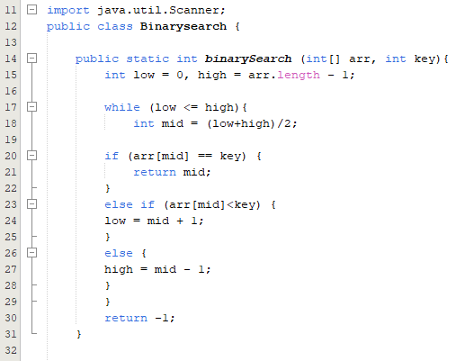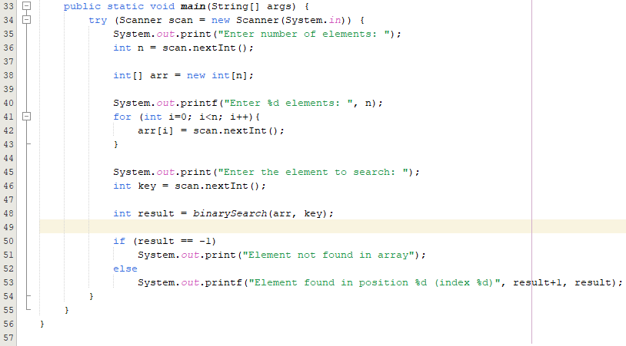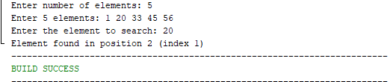

Write a Java function to arrange the elements of an array in ascending order (Sorting).
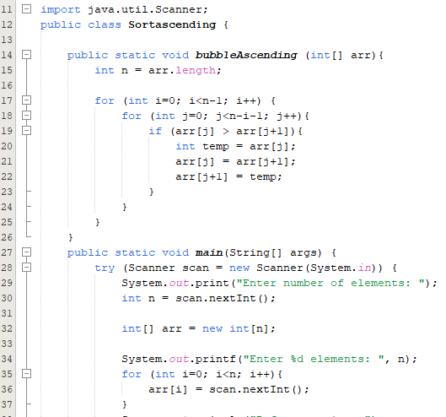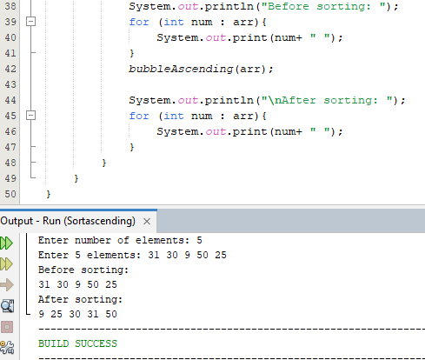

Write a program to reverse a given string.
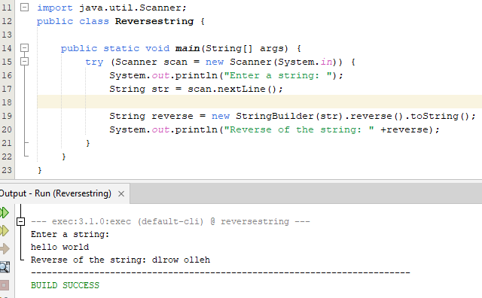

Write a program to check whether a given string is palindrome or not.
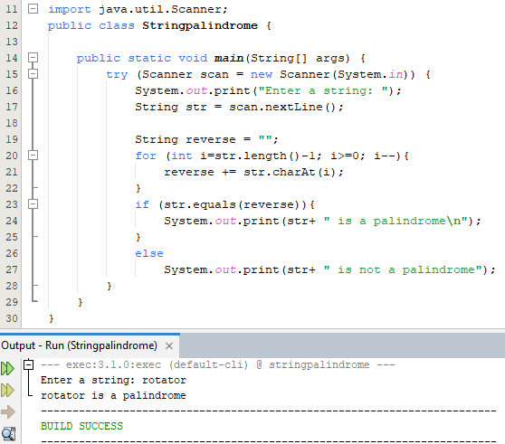

Write a program to implement factorial of a number through recursion.

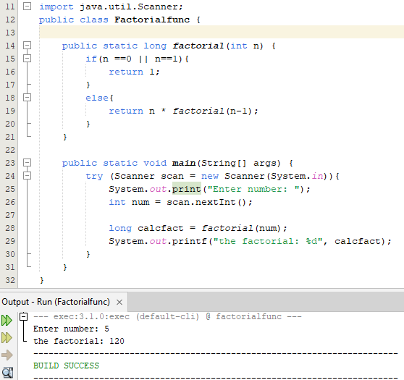

Write a program to implement Fibonacci series of a number with and without recursion.
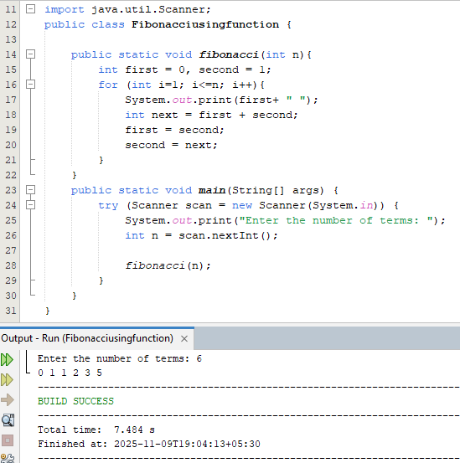

Write a Java function to find the greatest common divisor (GCD) of two numbers with and without using recursion.
